

UIT University
Department of Computer Science
CS/SE/AI/DS
FINAL YEAR PROJECT REPORT
Batch-2023
GROUP NO: CS_01

Predictive Analysis of Cyber Threat Intelligence Using AI, DFI, and Block chain Security (SHA-256)

By
Bilal Ahmed | 23SP-061-CS
Sarmad Khan | 23SP-007-CS
Zain Shamim | 23SP-014-CS
Hanzala Irfan | 23SP-053-CS

Supervised by
Dr. Adnan Ahmed Siddiqui
Professor, Department of Computer Science

ST-13, Block 7, Gulshan-e-Iqbal, Abul Hasan Isphahani Road, Opposite Safari Park, P.O. Box 75300,
Karachi, Pakistan. Phone: 34978274-5; 34994305; 34982476; http://www.uit.edu

Declaration

I hereby declare that this project report is based on my original work except for citations and quotations which have been duly acknowledged. I also declare that it has not been previously and concurrently submitted for any other degree or award at UIT University or other institutions.

Bilal Ahmed: | 23SP-061-CS
Signature: | _________________________
Sarmad Khan: | 23SP-007-CS
Signature: | _________________________
Zain Shamim: | 23SP-014-CS
Signature: | _________________________
Hanzala Irfan: | 23SP-053-CS
Signature: | _________________________
Date: | _________________________

Acknowledgments
We would like to sincerely thank Dr. Adnan Ahmed Siddiqui, our supervisor, for his guidance during the project. We are also grateful to UIT University for fostering an environment that promoted innovation and hands-on learning.

Abstract

This project introduces a Predictive Cyber Threat Intelligence (CTI) Framework a multi-layered security system that combines Artificial Intelligence, Deep Flow Inspection (DFI), unsupervised clustering, and blockchain-grade forensic integrity. Where traditional Intrusion Detection Systems (IDS) only react after an attack, this framework is designed to stay ahead of threats.
The system uses supervised machine learning models (Random Forest and XGBoost) for real-time attack classification, Deep Learning Autoencoders to detect zero-day anomalies, and K-Means/DBSCAN clustering to identify hidden behavioral patterns and botnet activity. Rather than decrypting traffic, it inspects behavioral fingerprints packet velocity, timing variation, and flow symmetry keeping user privacy intact.
An NLP module powered by spaCy and DistilBERT automatically extracts threat indicators (IP addresses, CVEs, malware names) from raw intelligence text, saving analysts significant manual effort. Every AI decision is explained through SHAP-based Explainable AI (XAI), so analysts always know why an alert was triggered. Logs are secured with SHA-256 hash chaining, making them tamper-proof and forensically sound. Everything is unified in an interactive Streamlit dashboard for threat monitoring, predictions, visualizations, and log verification.

Table of contents
Contents
Declaration 1
Acknowledgments 2
Abstract 3
Table of contents 4
List of tables 6
List of figures 7
List of symbols and Units: 8
1. Introduction 9
1.1 System Diagram: 10
2. Background and Literature Review 11
2.1 Existing Solutions 19
2.1.1 Hybrid Based ML IDS………………………………………………………..19
2.1.2 IBM XForce ThInt…………………………………………………………… 20
2.1.3Snort IDS with Grafana Dashboard………………………………………...21
2.2 Detailed Comparison Table…………………………………………………..22
3. Aim and Statement of Problem 24
4. Hardware, Software analysis and requirements 25
4.1 Activity Diagram................................................................................................26
4.2 Use Case Diagram..............................................................................................27
4.3 Non-Working Prototype.....................................................................................28
2. Software design and modeling 26
3. Algorithm analysis and complexity 27
4. Implementation 28
5. Testing 29
6. Discussion (optional) 30
7. Conclusions 31
8. Future work 32
9. Achievements 33
10. Appendices 34
11. General Guidelines 35
11.1 Printing and Binding: 35
11.2 Typing and size of paper 37
11.3 Page number and Chapter number 37
11.4 Margin boundaries 38
11.5 Diagrams and figures 38
11.6 Photocopying 39
11.7 Fixing of photograph 39
11.8 Tables 39
11.9 Equations 40
11.10 Units 40
11.11 References 40
11.11.1 Citations/references with multiple authors 41
11.11.2 Reference examples 41
11.11.3 Book 41
11.11.4 Book chapter 41
11.11.5 Electronic Book 42
11.11.6 Journal article 42
11.11.7 E-Journal article 42
11.11.8 Conference papers 43
11.11.9 Reports 43
11.11.10 Patents 43
11.11.11 Standards 44
11.11.12 Theses/Dissertations 44
11.11.13 Datasheets 44
11.11.14 Online Documents 44
11.11.15 Websites 45

List of tables

Table 2.1 Comparison of Algorithms

Table 2.2 Detailed Comparison Table of Existing CTI Solutions

List of figures
Figure 1:System Diagram 9
Figure 2:Comparison table of Algorithm Accuracy 15
Figure 3:Table of Cyber Attacks Accuracy 16
Figure 4:Table of Hyper parameter Tuning 17
Figure 5:Image of Confusion Metrics 18
Figure 6:Image of Metrics 18
Figure 7:Image of Time Comparion 19
Figure 8:Image of Metrics Table 20
Figure 9:Image of Detection 20
Figure 10:Image of Hybrid ML 22
Figure 11:Image of IBM UI 23
Figure 12:Image of Grafana 27
Figure 13:Activity Diagram 28
Figure 14:Use Case Diagram 29
Figure 15:Non-working Prototype 30
Figure 16:Non Working Prototype 30

List of symbols and Units:
Abbreviation | Full Form | Description
CTI | Cyber Threat Intelligence | The core framework developed in this project
DFI | Deep Flow Inspection | Behavioral traffic analysis method (replaces DPI)
IDS | Intrusion Detection System | Traditional security monitoring system
ML | Machine Learning | Used for threat classification
DL | Deep Learning | Used in autoencoder-based anomaly detection
RF | Random Forest | Supervised ML classifier for attack prediction
XGB | XGBoost | Supervised ML classifier for attack prediction
AE | Autoencoder | Deep learning model for zero-day anomaly detection
KM | K-Means | Unsupervised clustering algorithm(Behaviourial analysis)
DBSCAN | Density-Based Spatial Clustering of Applications with Noise | Unsupervised clustering for better detection of outliers
PCA | Principal Component Analysis | Dimensionality reduction technique
NLP | Natural Language Processing | Used for threat intelligence text extraction
NER | Named Entity Recognition | spaCy-based extraction of IPs, CVEs, malware names
SHAP | SHapley Additive exPlanations | Feature-level explanation of ML predictions
SHA-256 | Secure Hash Algorithm – 256-bit | Cryptographic hashing for tamper-proof logs

Introduction

Cybersecurity has changed dramatically over the past decade. Organizations now face a wide spectrum of threats from DDoS attacks and brute-force intrusions to sophisticated zero-day exploits that leave no trace for legacy systems to catch. As internet traffic increasingly shifts to encrypted channels and attack methods grow more advanced, the limits of older security tools are becoming impossible to ignore. These tools were built for plaintext signature matching, a method that simply does not hold up against today's threat landscape.
Traditional Deep Packet Inspection (DPI) cannot peer inside encrypted payloads like HTTPS traffic, and its processing overhead is too costly for fast enterprise networks or resource-constrained IoT environments. Compounding this, standard log files often the only record of an incident can easily be altered or wiped by attackers, undermining entire forensic investigations.
This project proposes an advanced CTI Framework that addresses these gaps with an integrated, intelligent, and transparent approach. At its core, the framework replaces DPI with Deep Flow Inspection (DFI), which analyzes behavioral metadata timing variance, packet velocity, flow symmetry without reading packet contents. This keeps it effective even over encrypted traffic and suitable for high-speed environments.
Beyond network traffic, the system automatically parses unstructured threat intelligence reports, vulnerability databases, and security advisories to extract key indicators using NLP. Every prediction comes with a SHAP-based explanation, so analysts understand the reasoning behind each alert not just the conclusion. And with SHA-256 hash chaining applied across all logs, the audit trail is as immutable as blockchain-secured records.The result is a proactive, explainable cybersecurity platform built for real-world deployment across enterprise and IoT environments.

1.1 System Diagram:
Below system diagram outlines the Cyber Threat Intelligence System architecture, where an SOC Analyst interacts with the Frontend UI (comprising SOC Access, Live Traffic Chart, Forensic Log, and Hash Validator) which communicates via REST/JSON through a POST /api/predict endpoint to the Backend ML Engine. The backend processes incoming traffic through Data Preprocessing, classifies it using an ML Model (RF/XGBoost) and Attack Classifier (DDoS/Normal/Anomaly), and secures records via the Forensic Logger all models trained on the CIC-IDS Dataset, as shown in Figure 1.

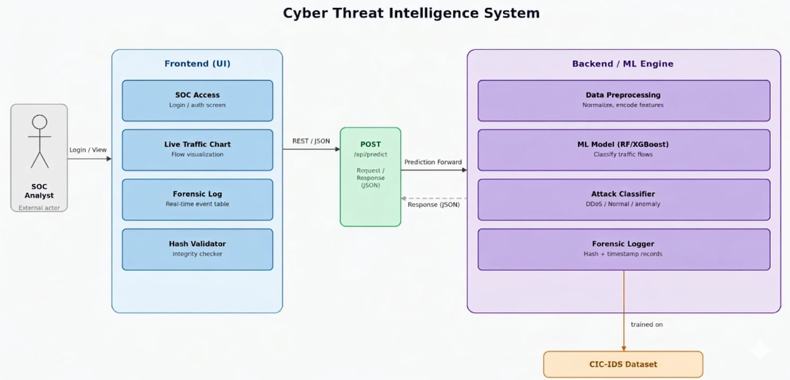

Figure 1: System Diagram

2. Background and Literature Review

Network-Based Intrusion Detection System

Network-based IDSs systems are based on capturing network traffic and analyzing it to detect any potential intrusion, such as DoS attacks, port scanning, and botnets. Internally, a network-based IDS can use a signature-based approach and compare the collected information with a signature database to look for a match with an intrusion, or it can work as anomaly-based system and compare current behavior with normal behavior to decide whether there is an attack.
NIDS provides a high-level vantage point, allowing for the detection of reconnaissance and lateral movement before an individual host is compromised. In the context of this project, the NIDS acts as a behavioral sensor for the entire network highway.

The Hybrid Learning Dichotomy
Supervised Learning utilizes labeled datasets to recognize known attack signatures with high precision. Unsupervised Learning models "normal" behavior and flags deviations as potential anomalies. Project utilizes a Hybrid Approach, bridging these two paths to ensure the system can identify both historical, documented threats and novel, "Zero-Day" attacks that lack existing labels.

Explainable AI (XAI) and Decision Transparency
Explainability, implemented via frameworks like SHAP (SHapley Additive exPlanations), provides feature attribution. This allows a SOC analyst to understand why a specific flow was flagged for that instance, identifying a 500% spike in packet frequency thereby fostering trust and enabling rapid human verification. (Explaining the AI Core results).

Cryptographic Integrity and Digital Forensics

To ensure that security logs are admissible for investigation, we employ SHA-256 Hashing. This cryptographic algorithm generates a unique digital fingerprint for every log entry. If a log is altered after being recorded, the hash will change, providing a robust mechanism for Tamper Detection and ensuring the integrity of forensic evidence.

Signature-Based vs. Anomaly-Based Strategies
Historically, intrusion detection was Signature-Based, comparing traffic to a database of known malware strings. While effective for known threats, this strategy fails against polymorphic code. The modern Anomaly-Based Strategy focuses on behavior; by analyzing features such as Flow Duration, Symmetry, and Inter-Arrival Times (IAT), the system identifies shifts in network "tempo" that indicate an ongoing breach, regardless of the malware's signature.

Deep Flow Inspection (DFI) and Feature Extraction
Rather than performing Deep Packet Inspection (DPI) which is computationally expensive and often blocked by encryption this project utilizes Deep Flow Inspection (DFI). DFI analyzes the statistical properties of a "flow" (a sequence of packets between two points). By extracting behavioral features (e.g., packet counts, byte rates), the system creates a numerical profile of the traffic, which serves as the primary input for the detection engines.

Multi-Stage Detection Strategy
The strategic core of this architecture is its Dual-Engine flow:
- The Classification Layer: Uses boosting algorithms to categorize standardized threats found in established benchmarks like the CIC-IDS dataset.
- The Anomaly Layer: Uses reconstruction-based models to catch outliers that do not fit the "Normal" traffic profile, ensuring no unknown threat goes undetected.

Ensemble Learning: Random Forest (RF)
Random Forest is a "Bagging" technique that constructs a multitude of decision trees and outputs the class that is the mode of the classes. Its strength lies in its ability to handle High-Dimensional Data (such as the 80+ columns in our DFI dataset) without overfitting. It serves as a robust baseline for identifying complex, non-linear patterns in network traffic.

Gradient Boosting: XGBoost
XGBoost (Extreme Gradient Boosting) is the primary supervised engine for this project. Unlike RF, which builds trees in parallel, XGBoost builds them sequentially, where each new tree corrects the errors of the previous ones. It is selected for its superior Processing Speed and built-in L1/L2 Regularization, which prevents the model from being confused by the "noise" typically found in live network environments.

Reconstruction-Based Models: Autoencoders
To address the "Zero-Day" challenge, we utilize Autoencoders (a type of Neural Network). The strategy involves training the model to compress and then reconstruct "Normal" network traffic. When presented with an attack flow, the model fails to reconstruct it accurately; the resulting Reconstruction Error acts as a definitive signal for an anomaly.

Behavioral Clustering: DBSCAN/K-Means
For grouping similar attack types, Clustering algorithms are employed. By measuring the "distance" between different malicious flows in a multi-dimensional space, the system can identify coordinated botnet activity. This allow the analyst to see if multiple different IPs are part of the same distributed attack campaign.

COMPARISION OF ALGORITHM
2.1 Comparison: Random Forest vs XGBoost vs Autoencoder vs K-Means

Overview
Feature | Random Forest | XGBoost | Autoencoder | K-Means
Model Type | Ensemble (Bagging) | Ensemble (Boosting) | Neural Network | Clustering Algorithm
Learning Type | Supervised | Supervised | Unsupervised | Unsupervised
Main Purpose | Classification / Regression | High-accuracy prediction | Anomaly detection / Feature learning | Data grouping / clustering
Working Principle | Multiple independent trees | Sequential error correction | Encode–decode data | Distance-based grouping
Handles Non-linearity | Yes | Yes (better) | Yes | Limited
Accuracy | Good | Very High | Good (for anomalies) | Moderate
Speed | Fast | Medium | Slow | Fast
Complexity | Low | High | High | Low
Best Use Case | Baseline models | Optimized predictions | Detect unknown threats | Pattern grouping

Research Articles:
- Cybersecurity threats detection in intelligent networks using predictive analytics approaches references[1]

Findings
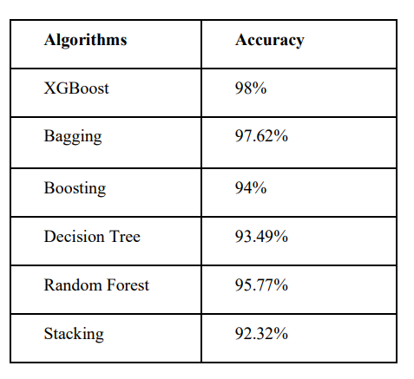
Figure 2: Comparison Table of Algorithm Accuracy
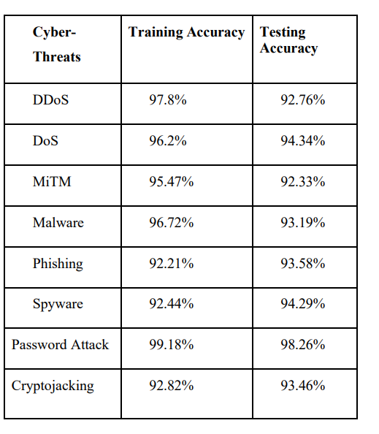
Figure 3: Table of cyber attack accuracy

2. Comparative Analysis of Random Forest and Xgboost Performance for Network Flow-Based Malware Classification references[2]

Findings:

Hyper parameter tuning:

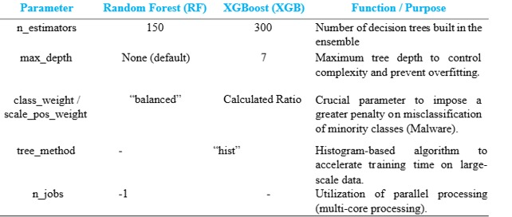
Figure 4: Table of Hyper Parameter tuning

Confusion matrix:
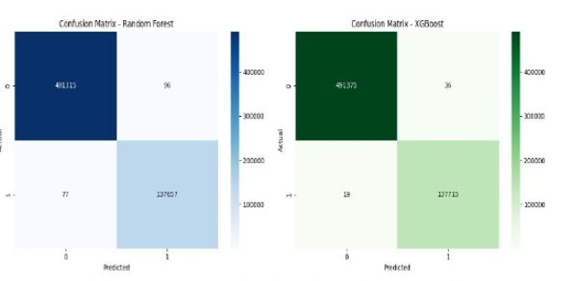
Figure 5: Confusion Matrix

Metrics:
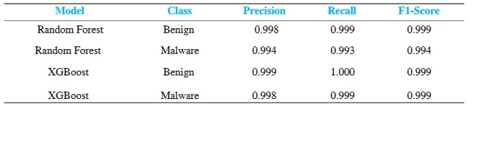
Figure 6: Metrics table

The most significant finding of this study lies in Inference Time efficiency. In a real-time Detection ecosystem, low latency is a critical parameter. The test results in Figure 6 show that XGBoost was able to complete predictions on ~600,000 test datasets in 6.36 seconds.

Time Comparison
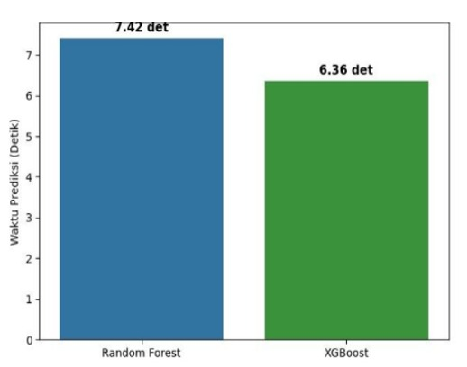
Figure 7: Time Comparion

3. A Hybrid Machine Learning Approach for Network Intrusion Detection with Real-Time Visualization references[3]

Findings

Metrics
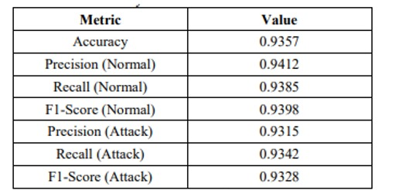
Figure 8: Metrics Table

Detection rate
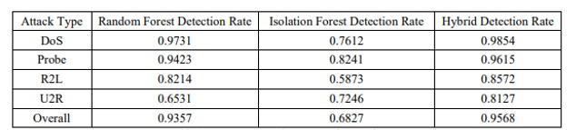
Figure 9: Table of Detection Rate

2.1 Existing Solutions
2.1.1 Hybrid ML-based IDS combining Random Forest (supervised) and Isolation Forest (unsupervised) with a real-time Streamlit dashboard, evaluated on the CICIDS2017 dataset.

Description:
This paper proposes a hybrid Intrusion Detection System that combines Random Forest for classifying known attacks and Isolation Forest for detecting novel anomalies in network traffic. Using the CICIDS2017 dataset with custom feature engineering, the system achieves an overall detection rate of 95.68%. A real-time Streamlit dashboard provides security analysts with live traffic monitoring and interactive visualizations. While results are promising, the system is limited by its binary classification approach and unvalidated performance in high-throughput production environments.

Key Features:
- Dual-model detection: Random Forest classifies known attacks (93.57% accuracy) while Isolation Forest catches novel/zero-day anomalies, with the hybrid achieving 95.68% overall detection rate.
- Custom feature engineering beyond the original 41 dataset features, adding traffic ratios, error patterns, and behavior indicators that significantly boost discriminative power.
- Real-time Streamlit dashboard giving analysts live traffic monitoring, per-second intrusion counts, and model predictions in an interactive interface.

Limitations:
- CICIDS2017 may not reflect the latest attack vectors, so real-world generalizability against modern threats is unvalidated.
- Real-time processing was only simulated — performance under actual high-throughput production traffic is untested.
- Binary classification only (normal vs. attack), with no granular multi-class attack categorization for incident response.

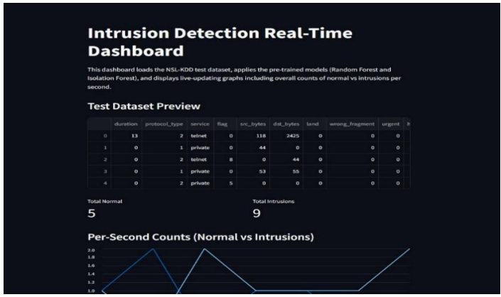
Figure 10: Hybrid ML-based IDS combining Random Forest (supervised) and Isolation Forest (unsupervised)

2.1.2 IBM X-Force Threat Intelligence

Description:
IBM X-Force Threat Intelligence is a global enterprise threat intelligence service that collects, analyzes, and delivers cyber threat insights to help organizations anticipate and mitigate emerging threats. It combines internal and external telemetry with expert research and automation.

Key Features:
- Real-time threat data and reports
- Tactical and strategic threat analysis
- Integration with security tools and automated feeds
- Global attack pattern visibility

Limitations:
- Advanced features often require enterprise plans
- High cost for smaller organizations
- AI capabilities focused more on enrichment than full predictive forecasting
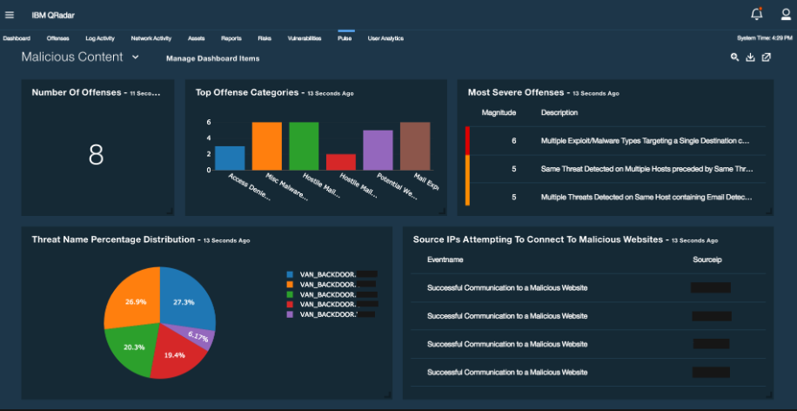
Figure 11: Image of IBM X-Force Threat Intelligence interface

2.1.3 Snort IDS with Grafana Dashboard

Description:
Snort is one of the most widely used open-source network intrusion detection and prevention systems (IDS/IPS). It analyzes real-time network traffic and applies rules/signatures to detect malicious patterns and attacks.

Key Features:
- Signature-based intrusion detection for attacks such as DoS, scans, and exploits.
- Real-time packet logging and alert generation.
- Integration with Elasticsearch, Graylog, or InfluxDB for data storage
- Grafana dashboards showing attack trends and network events.
- Visualization of source/destination IPs, protocols, and alert severity.

Limitations:
- It depends heavily on signature rules and may miss zero-day attacks
- Can generate high false positives without proper rule tuning
- Performance may degrade in high-traffic networks
- No built-in AI or predictive analytics capabilities
- Setup and maintenance require technical expertise
- Grafana only visualizes data; it does not analyze or predict threats
- No native blockchain or tamper-proof logging support
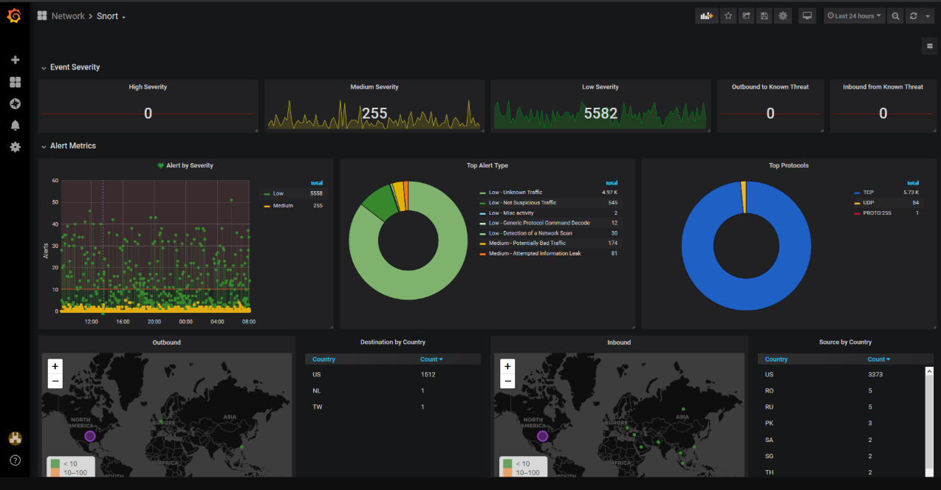

Figure 12: Image of Snort IDS with Grafana Dashboard

2.2 Detailed Comparison Table of Existing Cyber Threat Intelligence Solutions
This table presents a comparative analysis of Cyber Threat Intelligence platforms, including, Hybrid ML-based IDS combining Random Forest (supervised) and Isolation Forest (unsupervised) UI,IBM X-Force Threat Intelligence and Snort IDS with Grafana Dashboard

Aspect | Hybrid ML IDS (RF + IF + Streamlit) | IBM X-Force Threat Intelligence | Snort IDS with Grafana Dashboard
Purpose | • Detect known & zero-day intrusions  • Hybrid ML-based detection  • Real-time dashboard visualization | Enterprise-level cyber threat intelligence and threat awareness | Real-time network intrusion detection and traffic monitoring
Technology Used | • Python  • Random Forest, Isolation Forest  • Streamlit  • CICIDS2017 dataset  • Scikit-learn, Pandas | Cloud-based platform; AI-assisted analytics, big data, automation, global telemetry | Snort IDS (signature-based), Elasticsearch / InfluxDB / Graylog, Grafana
Key Features | • Dual-model detection (~93.57% accuracy)  • Anomaly scoring  • Feature engineering  • Real-time dashboard | • Real-time threat feeds  • Strategic & tactical intelligence reports  • Global attack pattern insights  • Automated threat enrichment | • Signature-based intrusion detection  • Real-time packet analysis  • Alert generation & logging  • Grafana-based visual dashboards
Integration Capabilities | • Standalone Python app  • Limited integrations | • Integrates with SIEM, SOAR, and enterprise security tools  • API-based intelligence sharing | • Integrates with databases (Elasticsearch, InfluxDB)  • Compatible with Grafana for visualization
Additional Functionalities | • Self-contained Streamlit dashboard  • Feature importance scoring  • Simulated real-time pipeline | • Expert research-backed insights  • Automated intelligence feeds  • Risk prioritization | • Visualization of IPs, protocols, attack trends  • Custom dashboards for monitoring
Strengths | • Combines supervised + unsupervised ML  • Better detection coverage  • High accuracy  • Interactive dashboard | • High-quality global intelligence  • Enterprise-grade reliability  • Strong integration ecosystem | • Lightweight and widely adopted  • Highly configurable rules  • Effective for known attack detection
Limitations | • Binary classification only  • Simulated real-time processing  • Limited dataset coverage  • No production validation | • Expensive for small organizations  • Limited predictive AI capabilities  • Vendor lock-in risk | • No AI or predictive analytics  • High false positives if poorly tuned  • Cannot detect zero-day attacks  • No blockchain or tamper-proof logging

3. Aim and Statement of Problem
Modern cybersecurity tools were not built for the threats we face today. Most deployed IDS systems are still signature based, they can only detect attacks they have already seen and have no capability to anticipate new ones [4]. No existing platform meaningfully combines machine learning-based prediction with unsupervised behavioral detection in a single, unified system.
The encryption problem makes this worse. Traditional Deep Packet Inspection cannot look inside HTTPS traffic, and the processing cost would be prohibitive anyway for high-speed networks or constrained IoT devices. Zero-day attacks compound the challenge further: because they exploit previously unknown vulnerabilities, there is no signature to match and no rule to trigger leaving systems blind until damage is already done [5].
Security teams are also overwhelmed by unstructured intelligence data threat reports, CVE advisories, vendor bulletins, and forum discussions. No existing system automatically pulls the critical details from this content, forcing analysts into slow, manual review cycles that do not scale [6].
When machine learning is applied in current tools, the models are typically opaque. They raise alerts without explanation, which erodes analyst trust, complicates decision-making, and creates compliance issues in environments where every security action must be documented and justified [7].
Log integrity is another weak point. Standard log files can be altered, deleted, or corrupted by attackers covering their tracks, yet none of the mainstream IDS or SIEM platforms apply cryptographic hash chaining by default. Finally, there is no integrated way to visualize how attackers, compromised systems, and security events relate to one another over time which means security teams often cannot tell whether a series of seemingly isolated incidents is actually a coordinated campaign, botnet activity, or a persistent threat actor working through their organization.

4. Hardware, Software analysis and requirements

System Modules
The system comprises three primary functional components: the Data Management Module, the Detection & Analysis Module, and the Forensic Visualization Module.
- Data Management Module: Handles the ingestion of network traffic (CIC-IDS dataset), Deep Flow Inspection (DFI) preprocessing, and feature scaling.
- Detection & Analysis Module: This is the core engine responsible for dual-stage detection. it implements the Autoencoder for anomaly filtering and XGBoost for specific attack classification.
- Forensic Visualization Module: Facilitates real-time monitoring through a Streamlit web interface, displaying live traffic charts, forensic logs, and SHA-256 integrity verification.

Hardware Requirements
The project is designed to be efficient and accessible. While enterprise-grade NIDS often requires high-end server hardware, this prototype is optimized for standard computing environments:
- Minimum Requirements: A standard laptop/PC with at least 8GB RAM and a modern quad-core CPU is sufficient for processing the sampled CIC-IDS dataset.
- GPU Acceleration: While higher-end GPUs (like an RTX 30-series) can speed up the training of the Autoencoder (TensorFlow), they are not strictly required for the inference scale of this prototype.
- Storage: Local or Cloud-based storage (MySQL/AWS RDS) is utilized to maintain the Forensic Integrity Logs.

Software Stack
- Programming Language: Python is the primary language for development, chosen for its robust ecosystem in data science and security.
- Machine Learning Frameworks: TensorFlow/Keras is used for building the Autoencoder, while the XGBoost library provides the supervised classification engine. Scikit-learn handles data preprocessing and scaling.
- Database & Security: MySQL is used for structured data storage, and the Hashlib library implements SHA-256 for forensic data integrity.
- Web Interface: Streamlit is utilized for the front-end dashboard, providing an interactive, web-based environment for SOC analysts without requiring specialized software installations.
4.1 Activity Diagram

This diagram shows a NIDS workflow where a SOC Analyst logs in, and the system validates credentials before loading the dashboard. Network traffic is then preprocessed, classified by an ML model, and either flagged as a threat (alert raised + forensic logging) or logged as normal traffic.

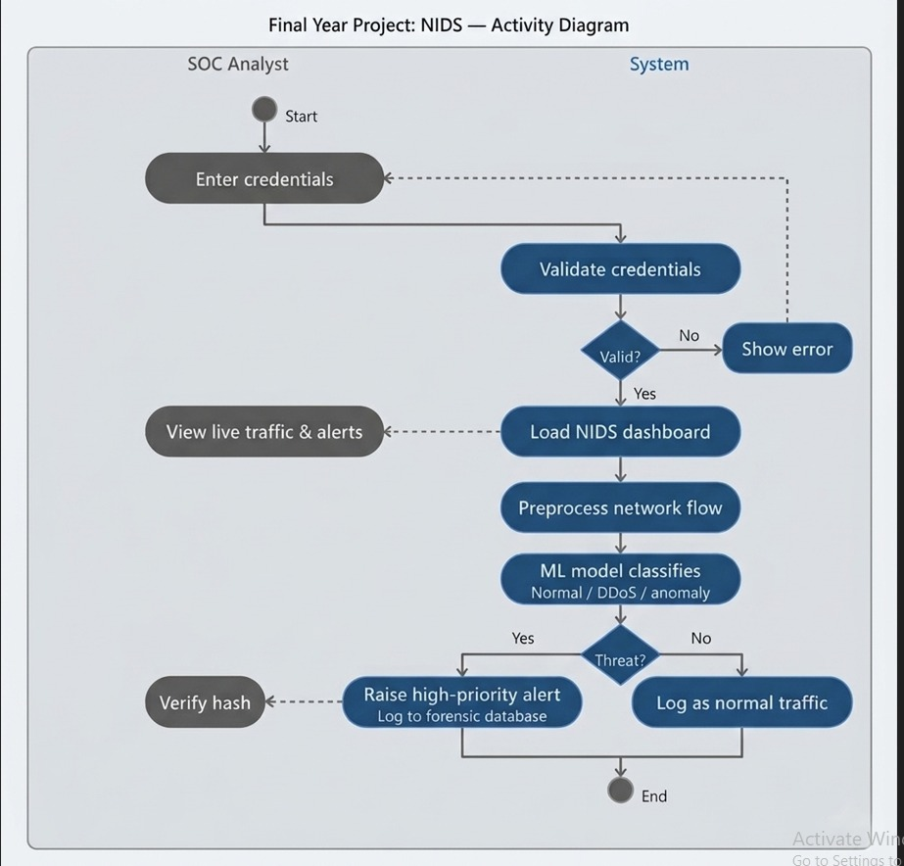
Figure 13: Activity Diagram

4.2 Use Case Diagram
This Use Case Diagram shows how a SOC Analyst and ML Engine interact with the Cyber Threat Intelligence System. The analyst logs in, views the dashboard, submits traffic data, verifies integrity hashes, and reviews forensic logs. Submitted traffic triggers a chain of ML processes — classification, anomaly detection, behavioral analysis, threat alert generation, and forensic logging.

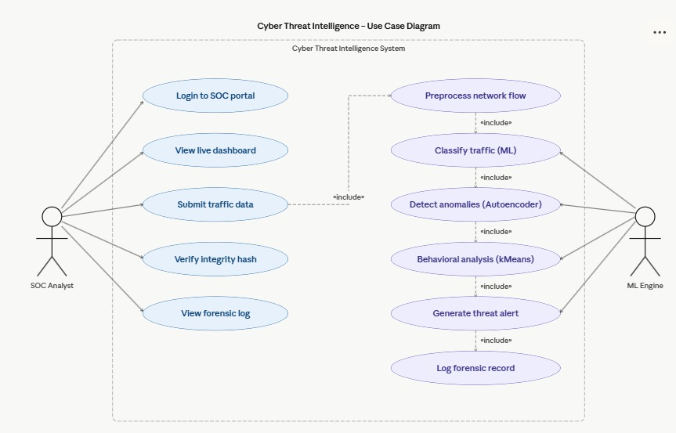
Figure 14: Use Case Diagram

4.3 Non Working Prototype:
The below images is the web view output of CTI shown in Figure 13, 14.

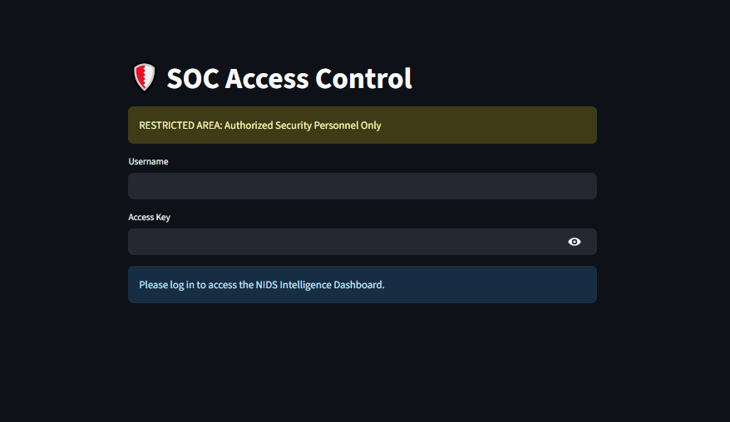
Figure 15

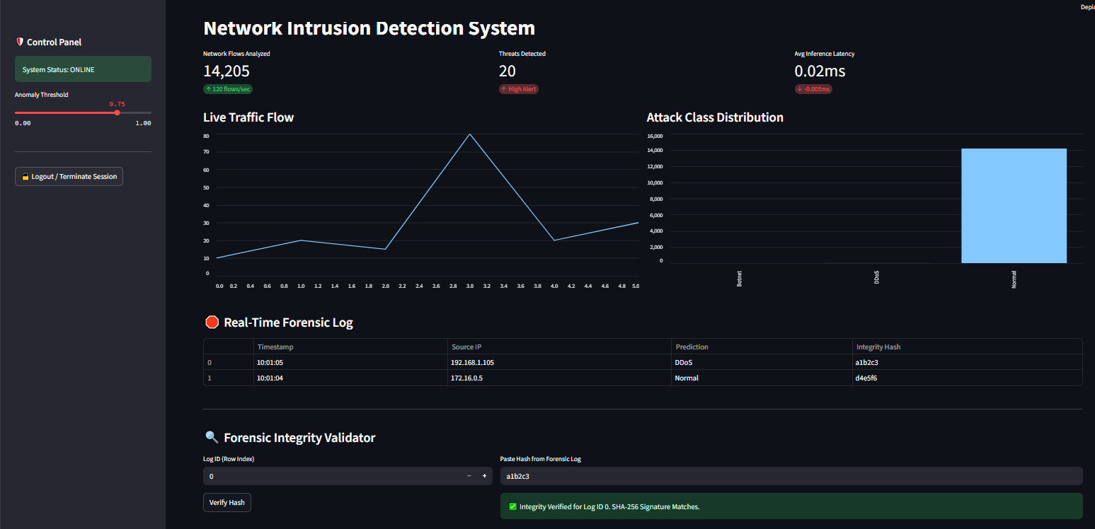
Figure 16

11.11 References

[1] Cybersecurity threats detection in intelligent networks using predictive analytics approaches
https://ub-ir.bolton.ac.uk/esploro/outputs/conferenceProceeding/Cybersecurity-threats-detection-in-intelligent-networks/999460808841/filesAndLinks?index=0

[2]Comparative Analysis of Random Forest and Xgboost Performance for Network Flow-Based Malware Classification
https://www.researchgate.net/publication/400947909_Comparative_Analysis_of_Random_Forest_and_Xgboost_Performance_for_Network_Flow-Based_Malware_Classification

[3].A Hybrid Machine Learning Approach for Network Intrusion Detection with Real-Time Visualization
https://www.indjcst.com/archiver/archives/a_hybrid_machine_learning_approach_for_network_intrusion_detection_with_real_time_visualization.pdf

[4] Signature-based IDS cannot detect unknown/zero-day attacks
Khraisat, A., Gondal, I., Vamplew, P., & Kamruzzaman, J. (2019). Survey of intrusion detection systems: Techniques, datasets and challenges. Cybersecurity, 2, 20. Springer
https://link.springer.com/article/10.1186/s42400-019-0038-7
[5] Zero-day attacks are widespread and traditional detection methods fail against them
Alauthman, M. et al. (2023). A review of Machine Learning-based zero-day attack detection: Challenges and future directions. Computer Communications, 198. Elsevier/ScienceDirect.

https://www.sciencedirect.com/science/article/abs/pii/S0140366422004248
[6] NLP is needed to automate CTI extraction from unstructured sources
Bousquet et al. (2024). Actionable Cyber Threat Intelligence using Knowledge Graphs and Large Language Models. arXiv / WACCO Workshop.
https://arxiv.org/html/2407.02528v1

[7] ML + XAI (SHAP) for real-time IDS is an active research need
Larriva-Novo, X. et al. (2023). Leveraging Explainable Artificial Intelligence in Real-Time Cyberattack Identification. Applied Sciences, 13(15), 8587. MDPI.
https://www.mdpi.com/2076-3417/13/15/8587

[8] MDPI — Cyber Threat Intelligence on Blockchain: A Systematic Literature Review
Authors: Dimitrios Chatziamanetoglou & Konstantinos Rantos
Title: Cyber Threat Intelligence on Blockchain: A Systematic Literature Review
Journal/Source: Computers (MDPI), Volume 13, Issue 3, Article 60, 2024
About: A systematic review exploring how blockchain technology is being used with Cyber Threat Intelligence (CTI) — covering models, methodologies, trends, and how blockchain's immutability, decentralization, and smart contracts enhance CTI data storage, sharing, trust, and security.
Link: https://www.mdpi.com/2073-431X/13/3/60
[9] MDPI — Blockchain-Based Cyber Threat Intelligence System Architecture for Sustainable Computing
Authors: Jeonghun Cha, Sushil Kumar Singh, Yi Pan, & Jong Hyuk Park
Title: Blockchain-Based Cyber Threat Intelligence System Architecture for Sustainable Computing
Journal/Source: Sustainability (MDPI), Volume 12, Issue 16, Article 6401, 2020
About: Proposes a blockchain-enabled architecture for CTI systems that improves reliability, privacy, scalability, and sustainability of cyber threat intelligence data collection and sharing. Experimental results show improved resource efficiency versus traditional architectures.
Link: https://www.mdpi.com/2071-1050/12/16/6401
[10] Nature — BlockIntelChain: a blockchain-based cyber threat intelligence sharing architecture
Authors: BlockIntelChain Research Contributors (Scientific Reports, Nature)
Title: BlockIntelChain: a blockchain-based cyber threat intelligence sharing architecture
Journal/Source: Scientific Reports (Nature), 2025
About: Introduces BlockIntelChain, a blockchain-based framework for decentralized, privacy-preserving CTI sharing, designed specifically for use with edge-deployed IoT and SOC environments. It highlights advantages over traditional CTI platforms (e.g., MISP, ThreatConnect) in decentralization, privacy, and cost efficiency.
Link: https://www.nature.com/articles/s41598-025-29152-6
[11] IEEE — Documentation of MITRE ATT&CK (Device & Adversary Tactics)
Authors: MITRE / IEEE contributors
Title: Documentation of Attack: MITRE ATT&CK Framework
Journal/Source: IEEE Xplore, 2019
About: Official IEEE publication describing the MITRE ATT&CK framework, a comprehensive knowledge base of real-world adversary tactics, techniques, and procedures (TTPs) used for documenting and analysing cyberattacks in a structured way. This documentation is widely used for intrusion detection, threat hunting, red-teaming, and defensive analytics.
Link: https://ieeexplore.ieee.org/document/8866762
[12] MITRE — Official ATT&CK Knowledge Base
Authors: MITRE Corporation
Title: MITRE ATT&CK®
Journal/Source: MITRE Corporation (Official Website), continuously updated
About: The leading industry knowledge base of cyber adversary behaviour — including detailed descriptions of tactics, techniques, sub-techniques, and procedures seen in actual attacks. Structured to help researchers, defenders, and incident responders map, detect, and mitigate threats.
Link: https://attack.mitre.org/
[13] MDPI — AI-Enabled IoT Intrusion Detection Framework
Authors: Antonio Villafranca, Kyaw Min Thant, Igor Tasic & Maria-Dolores Cano
Title: AI-Enabled IoT Intrusion Detection: Unified Conceptual Framework and Research Roadmap
Journal/Source: Machine Learning and Knowledge Extraction (MDPI), Volume 7, Issue 4, 2025
About: A comprehensive survey and conceptual framework for intrusion detection in IoT systems that highlights AI-based methods (ML/DL, federated learning, blockchain, XAI) to handle the unique security challenges in IoT environments — focusing on scalability, adaptability, and IDS performance metrics.
Link: https://www.mdpi.com/2504-4990/7/4/115
[14] Balantrapu (2024) — Predictive Cyber Threat Intelligence
Authors: S. S. Balantrapu
Title: AI for Predictive Cyber Threat Intelligence
Journal/Source: International Journal of Management Education for Sustainable Development, Vol. 7, No. 7, pp. 1–28, 2024
About: Explores how artificial intelligence techniques can be applied for predictive cyber threat intelligence, including trend forecasting, automated threat detection, and proactive incident analysis in enterprise security.
Link: https://ijsdcs.com/index.php/IJMESD/article/view/590
[15] Manoharan & Sarker (2023) — Next-Gen Threat Detection with AI & ML
Authors: Ashok Manoharan & Mithun Sarker
Title: Revolutionizing Cybersecurity: Unleashing the Power of Artificial Intelligence and Machine Learning for Next-Generation Threat Detection
Journal/Source: International Research Journal of Modernization in Engineering Technology and Science, Vol. 4, Issue 12, 2023
About: Discusses how AI and ML revolutionize cybersecurity by improving threat detection, anomaly identification, and predictive capabilities.
Link: https://www.doi.org/10.56726/IRJMETS32644

[16] Zeadally, S. et al. (2020) — AI Capabilities to Improve Cybersecurity
Authors: Syed Zeadally, E. Adi, Z. A. Baig & I. A. Khan
Title: Harnessing Artificial Intelligence Capabilities to Improve Cybersecurity
Journal/Source: IEEE Access, Vol. 8, pp. 23817–23837, 2020
About: Detailed overview of AI techniques applied to cybersecurity systems including threat detection frameworks.
Link: https://ieeexplore.ieee.org/document/9162409
[17] Frontiers in AI — Deep Learning/Machine Learning Approach for Anomaly-Based NIDS (2025)
Authors: To be confirmed from article page
Title: A Deep Learning/Machine Learning Approach for Anomaly-Based Network Intrusion Detection
Journal/Source: Frontiers in Artificial Intelligence, 2025
About: Introduces a hybrid deep learning and ML framework that improves detection accuracy for network intrusion and anomaly traffic.
Link: https://www.frontiersin.org/articles/10.3389/frai.2025.1625891
[18] MDPI — HDLNIDS: Hybrid Deep-Learning-Based Network Intrusion Detection System (2023)
Authors: Emad ul Haq Qazi, Muhammad Hamza Faheem & Tanveer Zia
Title: HDLNIDS: Hybrid Deep-Learning-Based Network Intrusion Detection System
Journal/Source: Applied Sciences (MDPI), Volume 13, Issue 8, 2023
About: Proposes a hybrid combination of deep learning models for improved network intrusion detection performance.
Link: https://www.mdpi.com/2076-3417/13/8/4921
[19] arXiv — Interpretable Anomaly Detection in Network Intrusions (2024)
Authors: Hao-Ting Pai, Yu-Hsuan Kang & Wen-Cheng Chung
Title: Interpretable Anomaly Detection in Network Intrusions
Journal/Source: arXiv preprint, 2024
About: Proposes methods that combine anomaly detection with interpretation techniques for network intrusion datasets.
Link: https://arxiv.org/abs/2403.07959
[20] arXiv — LENS-XAI: Lightweight and Explainable Network Security (2025)
Authors: Muhammet Anil Yagiz & Polat Goktas
Title: LENS-XAI: Redefining Lightweight and Explainable Network Security through Knowledge Distillation and Variational Autoencoders for Scalable Intrusion Detection in Cybersecurity
Journal/Source: arXiv preprint, 2025
About: Lightweight and explainable intrusion detection model using knowledge distillation and variational autoencoders — ideal for scalable cyber defense.
Link: https://arxiv.org/abs/2501.00790
[21] ResearchGate/ScienceDirect DFI: A Malicious Behavior Detection Method (2017)
Authors: Yu-tong Guo, Yang Gao, Yan Wang & Meng-yuan Qin
Title: DPI & DFI: A Malicious Behavior Detection Method Combining Deep Packet Inspection and Deep Flow Inspection
Journal/Source: Procedia Computer Science (ScienceDirect / ResearchGate), 2017
About: Compares Deep Packet Inspection (DPI) and Deep Flow Inspection (DFI) methods for detecting malicious behavior in network traffic — foundational for privacy-preserving flow-based IDS.
Link: https://www.researchgate.net/publication/314298144
[22] IEEE — Deep Flow Inspection Framework Based on Horizontal Federated Learning (2022) [NEW — DFI]
Authors: Authors listed on IEEE Xplore
Title: The Deep Flow Inspection Framework Based on Horizontal Federated Learning
Journal/Source: IEEE Conference Publication, 2022
About: Proposes a DFI method using federated learning for privacy-preserving traffic identification locally on-device, with a lightweight CNN model (Simplified-MobileNet) for traffic identification under limited hardware. Directly supports the FYP's DFI module rationale.
Link: https://ieeexplore.ieee.org/document/9919969/
[23] Springer — Cyber Threat Intelligence Report Summarization with Named Entity Recognition (2025) [NEW — NLP/CTI]
Authors: Authors listed in Springer chapter
Title: Cyber Threat Intelligence Report Summarization with Named Entity Recognition
Journal/Source: Springer Nature, Communications in Computer and Information Science, 2025
About: Proposes a document summarization framework leveraging NER for cyber threat intelligence using publicly available data. Demonstrates NER integration with generative AI for effective CTI processing — directly relevant to the FYP's spaCy NER and DistilBERT zero-shot classification module.
Link: https://link.springer.com/chapter/10.1007/978-981-95-4674-9_24
[24] arXiv — LogStamping: A Blockchain-Based Log Auditing Approach for Large-Scale Systems (2025) [NEW — SHA-256/Log Integrity]
Authors: Authors listed on arXiv
Title: LogStamping: A Blockchain-Based Log Auditing Approach for Large-Scale Systems
Journal/Source: arXiv preprint, 2025
About: Presents a system using SHA-256 cryptographic hashing of log entries combined with blockchain immutability to produce tamper-proof, auditable logs for compliance and forensic purposes — directly supports the FYP's SHA-256 hash-chaining log integrity module.
Link: https://arxiv.org/pdf/2505.17236

Software design and modeling
In this chapter project architecture is presented (explain which architecture is used), overall design diagrams (complete object diagram, complete class diagram, database diagram, etc.) to be shown. (as such diagrams are usually huge in nature, it is appropriate to print in on A3 or bigger sheets, and then fold it to A4 size).use few behavioral diagrams (sequence diagram, timing diagram, activity diagram, state transition diagram, or composite diagram) only for core technical functionality of the project against use cases. Show application’s landing/main/home interface, also show high fidelity prototypes (input, output, inquiry, debugging, configuration, and wrapper) on (Image, Audio, video, text, tags, AR, VR) against specific use case.

Resources:
https://www.uml-diagrams.org/uml-25-diagrams.html
https://sysml.org/

Algorithm analysis and complexity
In this chapter you have to mention algorithms that are used in project. Its purpose and significance, along with its pseudocode. Compare your selected algorithm with such other algorithms. For each algorithm show its best, average, and worst values in context of time and space complexity. Show primary references of all mentioned algorithms.

Implementation
Give code details (not a complete listing, but description of key parts). Discuss the most important/interesting aspects. It probably won’t be possible to discuss everything- give a rationale for what you do. Code shall not be more than 3-5 pages. Use appropriate code writing standards, draw operational diagram, component diagram and deployment diagram. Show only two to three technical interfaces that represents the core project functionality with explanation (You may use POC interfaces). Draw state transition diagram of project interface (input, output, and processes).

Testing
This chapter contains White box of most logical code, and black box testing of that interfaces that represents core functionality of the project¹ (only show test cases and their results). Some of the system level structural and functional testing must be shown with the help of tools². You have to show test plan – how the program/system was verified. Put the actual test results in the annexure.
This chapter also covers results of different types of experiments/simulations that were carried out with the code written. Why were certain experiments in the simulation used and how did they affect the results? If there are very many graphs and tables associated with this Chapter they may be placed in annexure.

Resources:
- Pressman, Roger S. "Software Engineering: A practitioner’s approach." 9th Edition (2020), Chapter 19-21
- Perry, William E. Effective Methods for Software Testing, CafeScribe: Includes Complete Guidelines, Checklists, and Templates. John Wiley & Sons, 2007, Chapter 8

Discussion (optional)
This Chapter should fully and logically discuss the progression of the project including the methods used and the results of experimentation, or the design; in such a way that examiner can evaluate the worth of the project. The discussion should be backed by detailed reference to material in the testing chapter of the report.

Conclusions
This Chapter should be a concise statement of the conclusions which may be drawn from the work attempted. The reader needs to be convinced that the design will work. If Uncertainties remain, they should be pointed out, and alternatives, such as modifying performance specifications, should be spelled out to deal with foreseeable outcome.

Future work
This Chapter may be used to propose further work which may be carried out on the project in subsequent study projects. Suggestions of this type should be limited to proposals which involve significant amounts of work such as major modifications of equipment or development of student practical experiments/enhancement. If any component is developed, how it can be utilized with proper documentation. Any suggestion is to be given in sufficient detail to provide adequate information for a future student to be able to fully appraise the proposal. which other similar project can be developed by using same concept with different domain/technology.

Achievements
In this chapter you have to summarize your participations in different competitions, conferences, incubation activities, and exhibitions. It is desired to express your experience about such activities. Also mention what you achieved in such activities e.g experience, acknowledgement, certificates, souvenirs , and rewards. If it is in process show correspondence evidence.

Appendices
These shall be used to give detailed results that shall be summarized in main text. The normal practice is “Annex A, B, C…” and, when required, “Appendix (to annex) 1, 2, 3…..” They should identify on every page by running header. Following items should be included in appendices

In acknowledgement chapter, you may include official letters from organizations.
In introduction chapter 2-3 pages about organization for which you are developing the project
In background and literature review chapter, research paper that is basis of your project, details of similar projects, any UML diagrams from other sources that has strong relationship with your project
In hardware, software analysis and requirement, you may add hardware pacification, use case narrations, or detailed requirement specification document.
In software design and modeling chapter, you may add detailed design documents other than most significant.
In software algorithm and complexity, you may attach actual algorithm or its research paper.
In achievement chapter, you have to mention correspondence (letters, emails etc.), copy of certificate, pictures of participation specially at time of award ceremony.
You may add any detail that is summarized in any chapters but need more focus and clarity for reader.

General Guidelines
- Begin each chapter on new page.

- Each chapter should have small introduction at beginning of chapter. Introduction must link to previous chapter. It is a one or more than one paragraph but not more than one page that introduces the reader to the subject. The introduction presents basic background material, the history of the problem and contains the key sentence outlining the subjects to be discussed.

The total report length should be 100- 120 pages; most projects somewhat shorter. There is no value in trying to artificially lengthen your project by ‘padding’ it. Each project is unique and has its own natural length, and you will probably know when you have said everything that you need to be said.

Printing and Binding:
Two Hard bound copies (1 for supervisor, and 1 for library) per group of the project report. Hard bound means permanently stitched and bound in (Color #792c2f contains mainly RED color) with the title of the project and your name clearly inscribed on the cover as per format given at the first page of template in golden color.
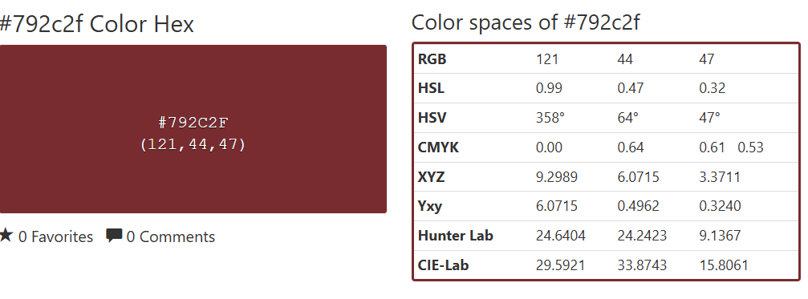

The SPINE of project report should have Group NO, title of the project and batch should be in horizontal orientation in the spine of hard bound copy of project.

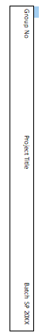

The SPINE of project report should have Group NO, title of the project and batch should be in horizontal orientation in the spine of hard bound copy of project.
Soft copy of project data to be submitted in G- drive, that is designated to each group by university, while maintaining the folder hierarchy mentioned below. Project data must be approved from respective supervisor.

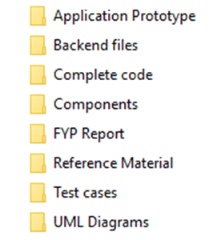

Typing and size of paper
I. The report is to be typewritten on one side of the paper on international size A4 paper (297mmX210mm). This paper must be good quality bond (70-90 gsm).
ii. Reports length should be 100-120 pages.
iii. Use Times New Roman, size 12 font throughout the reports.
Use 1.5 or double spacing.

Page number and Chapter number

- Use lower case Roman numerals for preliminary pages

I. Title page (not numbered on page)
- Abstract
- Table of Contents

The text of the report begins with Arabic number 1. Number all pages. Page numbers can be inserted either at the bottom/top right or the bottom/top center.
All appendices should number as A-1, A-2, etc. for pages under appendix A, and B-1, B-2, etc. for pages under appendix B (See Table of Contents.).
A hierarchical numbering scheme for chapter numbering shall be used. For instance, use 1 for chapter one, 2 for chapter 2, 1.1 for the subsection 1 of chapter 1, etc. (See the Table of Contents).

Margin boundaries

Top and Bottom = 2.5 cm
Left 4 cm, and Right = 2.5 cm

Diagrams and figures

Figures and table should be inserted in the text in one of the three places

A full page figure or illustration must be inserted on the left hand side facing the typescript which described it.
Small figure should be incorporated in the text with the legend appearing below (not recommended).
Each graph, figure, etc., should have a figure number and title typed below it. The type style should be same as the text. Figures should be numbered by chapters (Fig. 1.1, Fig 1.2, Fig. 2.1, etc). explain each figure by referring its number (e.g. in Fig 1.1), don’t assume any figure is self-explanatory. Whichever numbering system you use, make sure that you follow the same system for tables and equations, also explain then as figures.

Line drawings, graphs, and monograms should be in bold clear lines. Where graphs, diagrams and figures cannot be mounted vertically on the page these are to be mounted and labeled in such a way that they can be read from the right hand side(900 on the page) of the page .

All the axes of graphs are to be labeled with the parameter and its units. Information on illustrations and graphs such as labels, scales etc. must be typewritten.

Photocopying

All the figures, etc. must be reproduced by an electronic or electrostatic or photographic method which is known not to fade.

Fixing of photograph

Full page photographs should be bound into the report. Small photographs must be firmly fixed to the paper. An alternative is to use color photocopying or digital processing.

Tables

Each table should be numbered consecutively (Table 1, Table 2) or by chapter (Table 1.1, Table 1.2, Table 2.1).Table number should be center above the top of the table and be followed on the next line by a brief descriptive caption, preferably in cap. The type should be the same as the text. Refer to each table in text by number “In Table 1, one can clearly see………”The same rules for location of figures apply to tables.

TABLE 1. MEASURED RESISTOR VALUES AND THE METER ERROR
Nominal Value Marked | Measured Value | Error (%)

Equations

Centre each equation on separate line. Number equations consecutively in parentheses at the right margin. Equation may be referenced by number in the text, using parentheses around the number.

Y (t) = ∫sin (x) dx (1)

Units

The S.I. system of units is to be used throughout. Where difficulties are introduced by quotation of imperial units from reference source, these should be accompanied by the appropriate conversion to S.I. units in parentheses.

References
At the end of your work, list full details of all of the sources which you have cited in your text in a section headed References, in numeric order. References listed must follow IEEE formatting guidelines (see reference examples overleaf). Your reference list should allow anyone reading your work to identify and find the material to which you have referred.
In IEEE style your reference list should be formatted in the following way:
- Align references left
- Single-space each entry, double-space between every new entry
- Place number of entry at left margin, enclose in square brackets [ ] Indent text of entries

Citations/references with multiple authors
If you choose to mention the author(s) of a source whilst citing it in the text of your work, if there are three or more you can abbreviate them using ‘et al.’ e.g. During their research, Fan, et al. [4] discuss lasers in detail. However, in general you do not need to mention the authors by name, just use the numeric citation in square brackets. In your full reference list at the end however, you always give the authors’ names. In the reference list you can only abbreviate these using ‘et al.’ if there are six or more authors.

Reference examples
There are standard reference formats for most types of document. Below are examples of the most common types of document you might want to reference. Each of the following gives a suggested standard format for the reference followed by examples for the different document types.

Book
[Ref number] Author’s initials. Author’s Surname, Book Title, edition (if not first). Place of publication: Publisher, Year.

[1] I.A. Glover and P.M. Grant, Digital Communications, 3rd ed. Harlow: Prentice Hall, 2009.

Book chapter

[Ref number] Author’s initials. Author’s Surname, “Title of chapter in book,” in Book Title, edition (if not first), Editor’s initials. Editor’s Surname, Ed. Place of publication: Publisher, Year, page numbers.

[2] C. W. Li and G. J. Wang, "MEMS manufacturing techniques for tissue scaffolding devices," in Mems for Biomedical Applications, S. Bhansali and A. Vasudev, Eds. Cambridge: Woodhead, 2012, pp. 192-217.

Electronic Book
[Ref number] Author’s initials. Author’s Surname. (Year, Month Day). Book Title (edition) [Type of medium]. Available: URL
[3] W. Zeng, H. Yu, C. Lin. (2013, Dec 19). Multimedia Security Technologies for Digital Rights Management [Online]. Available: http://goo.gl/xQ6doi
Note: If the e-book is a direct equivalent of a print book e.g. in PDF format, you can reference it as a normal print book.

Journal article

[Ref number] Author’s initials. Author’s Surname, “Title of article,” Title of journal abbreviated in Italics, vol. number, issue number, page numbers, Abbreviated Month Year.

[4] F. Yan, Y. Gu, Y. Wang, C. M. Wang, X. Y. Hu, H. X. Peng, et al., "Study on the interaction mechanism between laser and rock during perforation," Optics and Laser Technology, vol. 54, pp. 303-308, Dec 2013.

Note: the above example article is from a journal which does not use issue numbers, so they are not included in the reference.

E-Journal article

PDF versions of journal articles are direct copies of the print edition, so you can cite them as print journals.

[Ref number] Author’s initials. Author’s Surname. (Year, Month). “Title of article.” Journal Title [type of medium]. volume number, issue number, page numbers if given. Available: URL

[5] M. Semilof. (1996, July). “Driving commerce to the web-corporate intranets and the internet: lines blur”. Communication Week [Online]. vol. 6, issue 19. Available: http://www.techweb.com/se/directlinkcgi?CWK19960715S0005

When you are compiling your reference list you may abbreviate journal titles:

For a list of IEEE abbreviations go to:
https://www.ieee.org/documents/trans_journal_names.pdf

For non IEEE journal abbreviations go to: http://www.bath.ac.uk/library/help/infoguides/abbreviations.html

For further information on the common abbreviations of words used in references for the IEEE style go to:
http://www.ieee.org/documents/style_manual.pdf

Conference papers
[Ref number] Author’s initials. Author’s Surname, “Title of paper,” in Name of Conference, Location, Year, pp. xxx.

[6] S. Adachi, T. Horio, T. Suzuki. "Intense vacuum-ultraviolet single-order harmonic pulse by a deep-ultraviolet driving laser," in Conf. Lasers and Electro-Optics, San Jose, CA, 2012, pp.2118-2120.

Standard abbreviations may be applied to the title of the conference. For a table of abbreviations go to: http://www.ieee.org/documents/ieeecitationref.pdf

Reports

The general form for citing technical reports is to place the name and location of the company or institution after the author and title and to give the report number and date at the end of the reference. If the report has a volume number add it after the year.

[Ref number] Author’s initials. Author’s Surname, “Title of report,” Abbreviated Name of Company., City of Company., State, Report number, year.

[7] P. Diament and W. L. Luptakin, “V-line surface-wave radiation and scanning,” Dept. Elect. Eng., Colombia Univ., New York, Sci Rep. 85, 1991.

Patents

[Ref number] Author’s initials. Author’s Surname, “Title of patent,” Country where patent is registered. Patent number, Abbrev of Month Day Year.

[8] J. P. Wilkinson, “Nonlinear resonant circuit devices,” U.S. Patent 3 624 125, July 16 1990.

Note: Use “issued date” if several dates are given.

Standards

[Reference number] Title of Standard, Standard number, date.

[9] Shunt power capacitors, IEEE standard 18-2012, 2013.

Theses/Dissertations

[Ref number] Author’s initials. Author’s Surname, “Title of thesis,” Designation type, Abbrev. Dept., Abbrev. Univ., City of Univ., State, Year.

[10] J. O. Williams, “Narrow-band analyser,” Ph.D. dissertation, Dept. Elect. Eng., Harvard Univ., Cambridge, MA, 1993.

Datasheets

[Ref number] Author’s initials. Authors Surname, “Title of Datasheet,” Part datasheet, Publication date [Latest revision date].

[11] Texas Instruments, “High speed CMOS logic analog multiplexers/demultiplexers,” 74HC4051 datasheet, Nov. 1997 [Revised Sept. 2002].

Online Documents

If you are using documents such as a report, conference paper, standard, patent or thesis online and it also exists as an identical print equivalent i.e. with the same format and pagination, it can be usually be referenced as the print version.

If it is e-only, you can make the standard reference template an electronic version by adding the material type in square brackets
e.g. [Online] after the document title. If there is no specific document title you can place this after the document number (e.g. patent number).

At the end of the reference add: Available: URL. See below for an example of an online patent:

[12] M.R. Brooks, “Musical toothbrush with adjustable neck and mirror,” U.S Patent 326189 [Online], May 19 1992. Available: http://goo.gl/VU1WEk

Websites

Note: Include as much of the key information as you can find for a given website. If a web page has no personal author, you can use a corporate author. Failing that, you can use either Anon. (for anonymous) or it is permissible to use the title of the site.

[Ref number] Author’s initials. Authors Surname. (Year, Month. Day). Title of web page [Online]. Available: URL

- BBC News. (2013, Nov. 11). Microwave signals turned into electrical power [Online]. Available: http://www.bbc.co.uk/news/technology-24897584

- M. Holland. (2002). Guide to citing internet sources [Online]. Available: http://www.bournemouth.ac.uk/library/using/guide_to_citing_internet_sourc.html
s

